Chat-Gpt
Create a professional promotional image for an airline advertisement featuring a modern commercial aircraft flying above soft clouds against a bright blue sky. Use premium blue and white brand colours, natural cinematic lighting, and a clean, sophisticated composition. Include a subtle modern airport terminal or scenic destination in the background to create a sense of travel, freedom, comfort, and adventure. Use a landscape layout with realistic, high-quality photography and a polished commercial advertising aesthetic. Do not include airline logos, text, slogans, or watermarks.

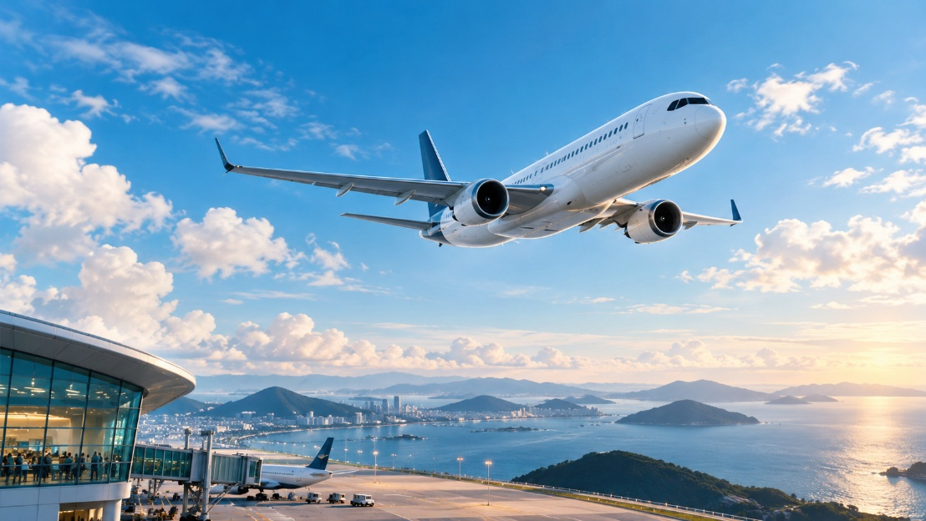

Canva
Create a professional promotional image for an airport social-media campaign featuring young travellers exploring a modern airport terminal. Use vibrant blue and white brand colours, natural lighting, diverse travellers, and engaging travel moments such as check-in, boarding, shopping, or relaxing in the lounge. Use a landscape layout with realistic, high-quality photography and a modern, energetic social-media advertising aesthetic. Do not include airline logos, text, slogans, hashtags, or watermarks.
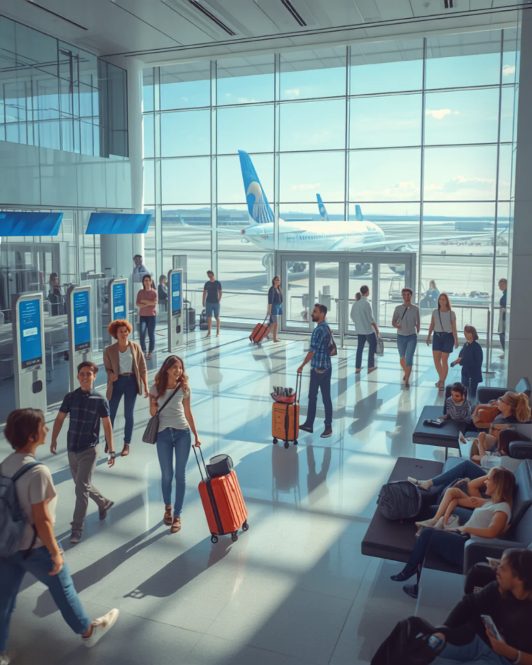

Gemini
Create a professional promotional image showcasing a beautiful travel destination with iconic landmarks, scenic landscapes, and local culture. Use vibrant yet elegant colours, natural lighting, and a premium travel-advertising aesthetic. Include tourists exploring the destination to create a sense of adventure, discovery, and memorable experiences. Use a landscape layout with realistic, high-quality photography and a clean, visually appealing composition. Do not include airline logos, text, slogans, or watermarks.
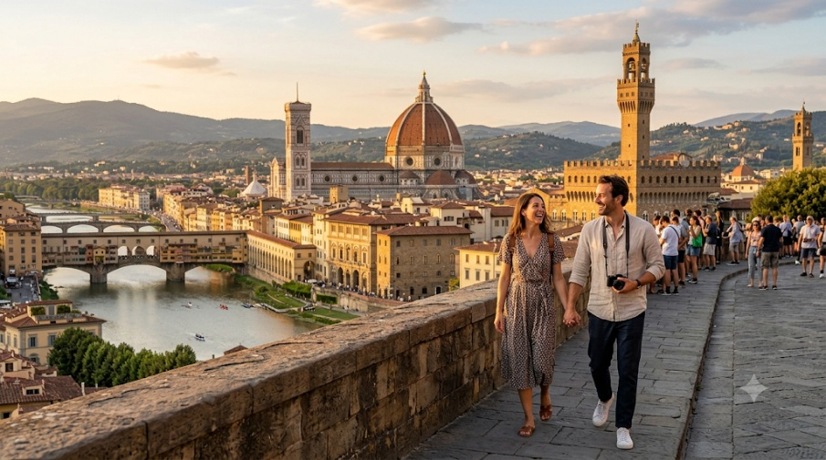

Micro soft co-pilot
Create a professional educational image for airport training materials featuring airport staff undergoing training in a modern airport environment. Show realistic scenes of staff learning airport operations, passenger assistance, safety procedures, or teamwork. Use blue and white brand colours, clean natural lighting, and a landscape layout. Maintain a professional, organized, and educational visual style suitable for aviation training and learning materials. Do not include airline logos, text, slogans, or watermarks.
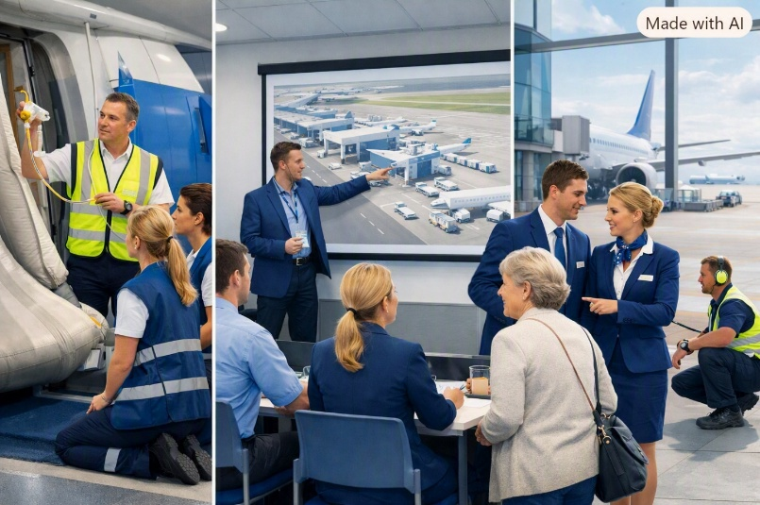

Leonardo.Ai
Create a professional awareness image for an airport passenger-awareness poster featuring travellers following airport safety, security, and travel procedures inside a modern airport terminal. Use blue and white brand colours, clear visual communication, natural lighting, and a landscape layout. Show realistic passengers interacting with security checkpoints, baggage, boarding areas, or airport staff in an organized environment. Maintain a clean, informative, and visually engaging style suitable for airport awareness campaigns. Do not include airline logos, text, slogans, or watermarks.
